Technical specifications CLIVIO CLV 12 grout mixer with pump

Serial number: 25-03-2026
Year of manufacture: 2026012073

Introduction:
CLIVIO started as manufacturers of grouting pumps in 1948 and is one of the main Italian specialized manufacturers. The experience acquired in so many years as specialized manufacturer, has ensured that Clivio developed and manufactures very reliable and up to date machines. The Clivio grout stations are recognized by smart engineering together with
a durable construction for maximum efficiency, easy operation and low maintenance.

This grout station consists of modular units like pump, agitator, waiting tank and the unit is powered by a durable electric motor. This means the unit is quiet in its operation and does not have any exhaust nor does it need to be refilled with fuel. This unit is designed and used mainly during the installation of grout anchors and soil improvement.

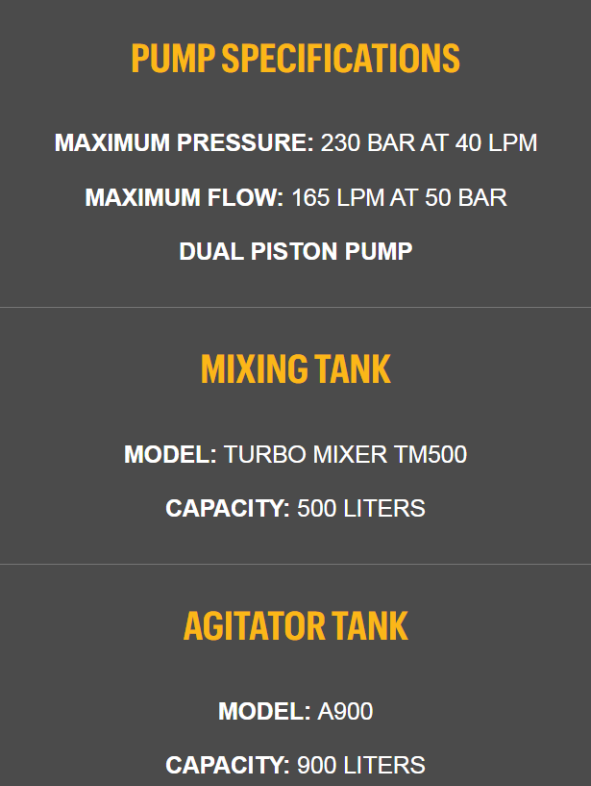
This Clivio grout unit consists of:

MINI JET
SN: GE2019M0690
YOM: 2019
Weight indication: 4200 KG

CLV12 JET SYNCRO PUMP
SN: IE2019M089
YOM: 2019
Pistons: 2

AGITATOR A900
SN: AE2019M0684
YOM: 2019
Unit weight: 390 kg
Capacity: 900 liter

TURBO MIXER TM500
SN: ME2019M0687
Unit weight: 550 kg
Tank capacity: 500 liter
Flow rate of impellor pump: 600 liter/min.
Motor power: 7,5 kW
Electric motor: Seipee 3 phase
Pressure: 2,5 bar
Production capacity: 5m3 per hour

